1. Nested Tables:

<!DOCTYPE html>

<html>

<head>

<title>Nested Table</title>

</head>

<body>

<table border="1px">

<tr>

<td>Left side of the main table</td>

<td>

<table border="1px" bordercolor="#FF0000">

<h4 align="center">Nested Table</h4>

<tr>

<td>nested table C1</td>

<td>nested table C2</td>

</tr>

<tr>

<td>nested table</td>

<td>nested table</td>

</tr>

</table>

</td>

</tr>

</table>

</html>

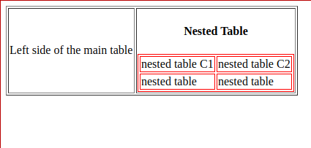

2. Image Mapping:

